Professional Study Tour - Slovenia

March 02/2019. - 23 March 2019, 6 students from Georgikon Greek Catholic Agricultural and Food Industrial Secondary and Vocational School and Student Hostel from Sátoraljaújhely participated in a 3 week internship in the town of Novo Mesto, Slovenia. I participated in a professional study trip from 2nd March until 16th March,2019.
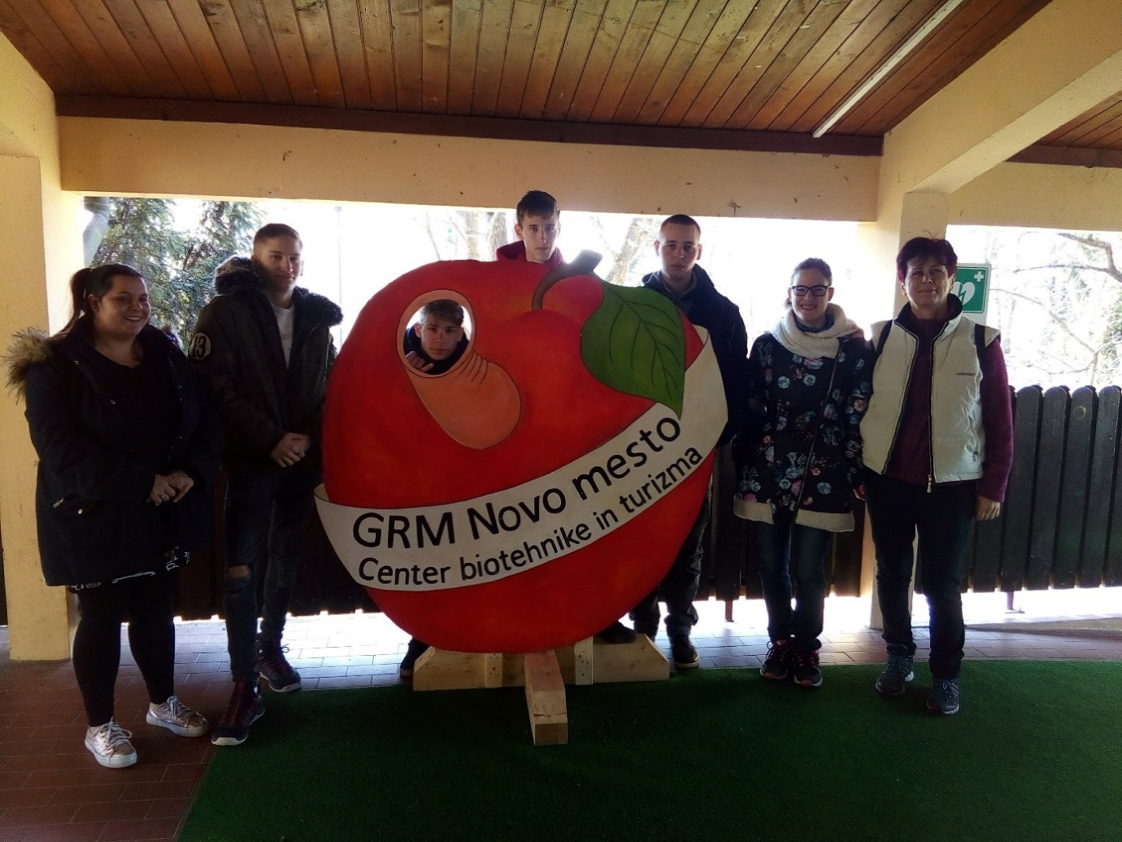

Since 2015, our school has a continuous relationship with the Slovenian school (GRM NOVO MESTO - center biotehnike in turizma Sevno), which is an institution with similar profile but larger-sized school.
Between 2015 and 2017, we have contacted the Slovenian partner during the planning and implementation of the VITEA (9 institutions out of 7 countries) within the framework of the Erasmus + Strategic Partnership. The training profile of the institution is as follows: in addition to agriculture and hospitality, tourism also includes industrial professions.

As a professional teacher and head of school, I studied the school's material and personal conditions and educational system.

Material conditions:
The central part of the school building is the lobby, which functions as a community space and a restroom also,the dining room is organically attached to this. Fits on the plate, satisfying every need (ICT, ergonomically chairs, tables, etc.). Spacious, bright, well-equipped workshops are available for publishing according to different professional groups: animal husbandry (horse, cattle, sheep), horticulture (apples, grapes, nursery, herbs), machine shop.

The spacious, bright, well-equipped workshops are distinguished according to the different groups: livestock farm (horses, cattles, sheep), horticulture (apples, grapes, nursery, herbs), workshops. In the center of the city there is a practical place for confectionery and for restaurant for the school students,and a vinotheque. We had lunch with our students there every day. The equipment and organization of the training places are exemplary and the focus is on education.

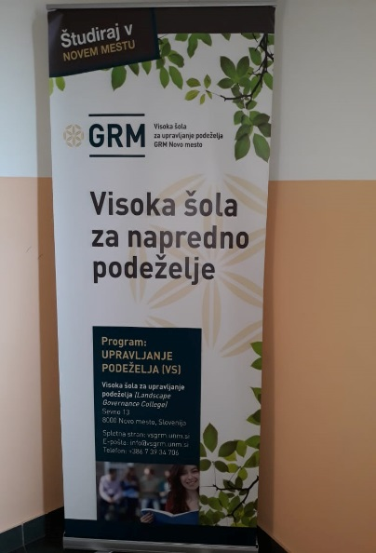

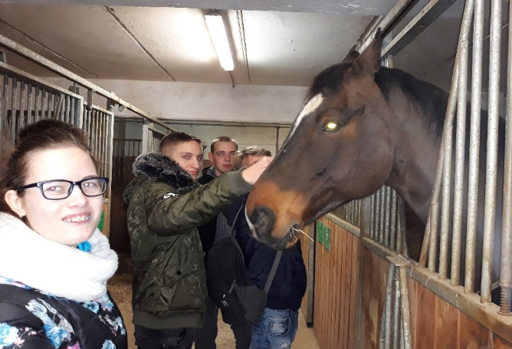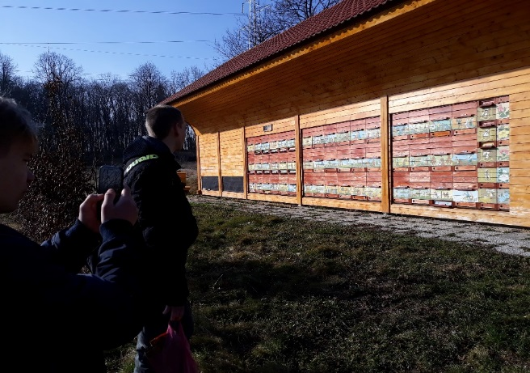

Our three agricultural mechanic professional group students attended a workshop with Slovenian students. They could work with modern agricultural machines as well.

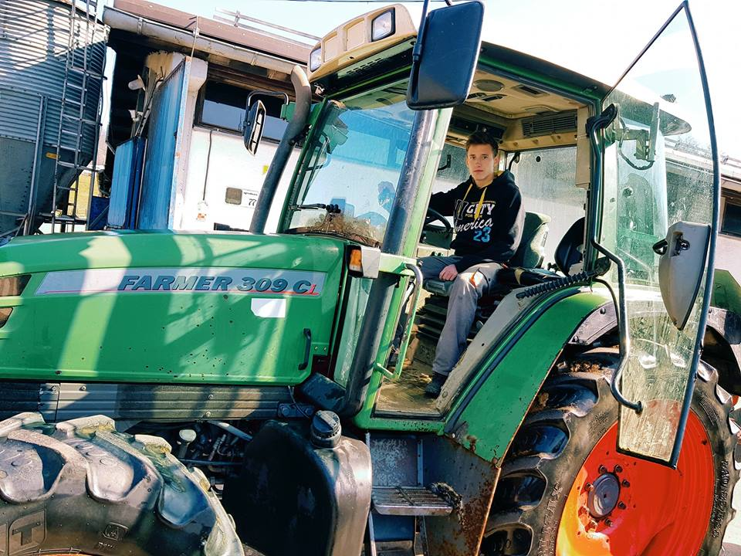

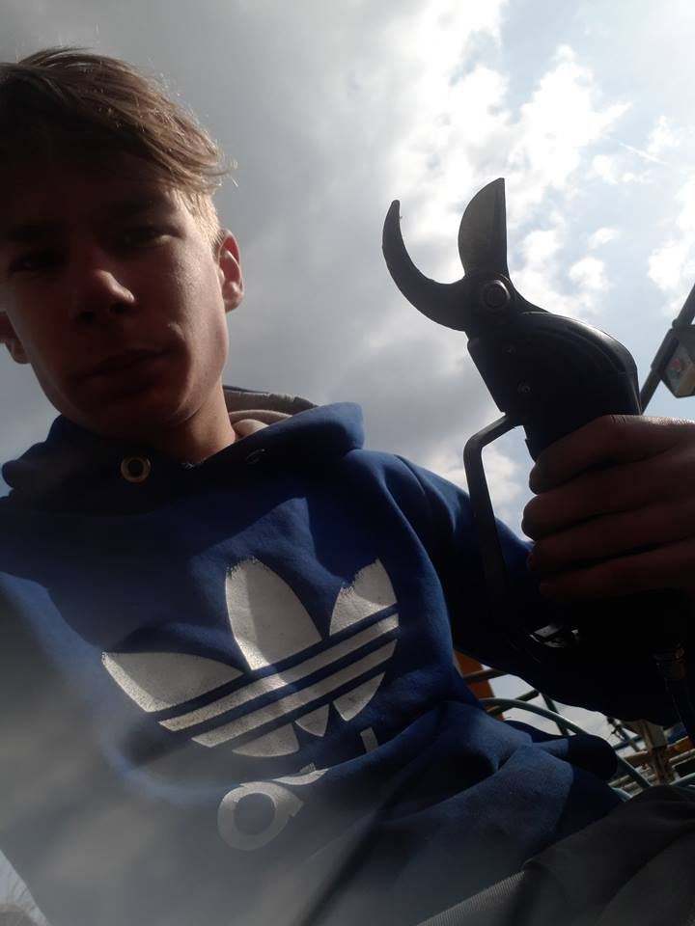

At the farm next to the school they were also took part in animal breeding and they took part and care of the animals. They could also study the machines operating here in details. A part of the school workshop burned shortly before we arrived. Our students also helped in unbuilding.

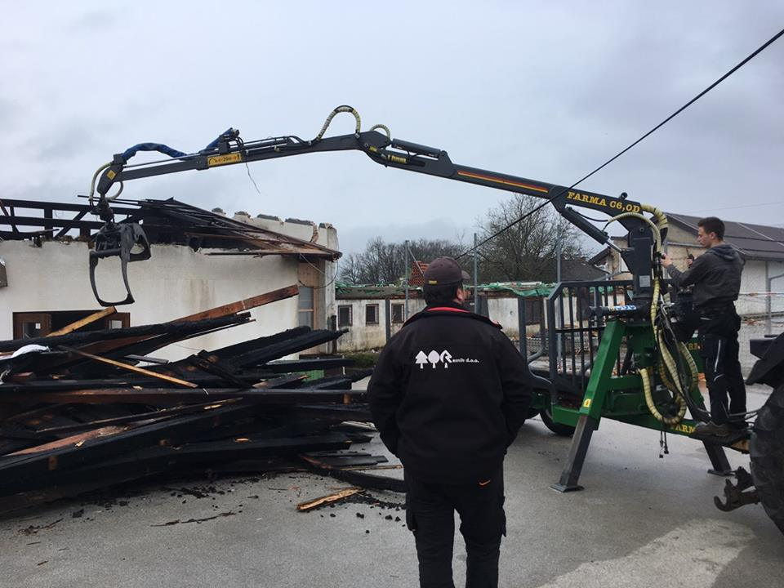

Two confectioners and one student in the food industrial training course spent three weeks in the school's confectionery workshop. Well-equipped training room also accommodates school students. From the start, our students got to know the whole process of making cakes and actively participated in it. Special desserts typical of the region were also made. On March 15th, our students made dices Somlói style for the Slovenian professional teacher and students as well.

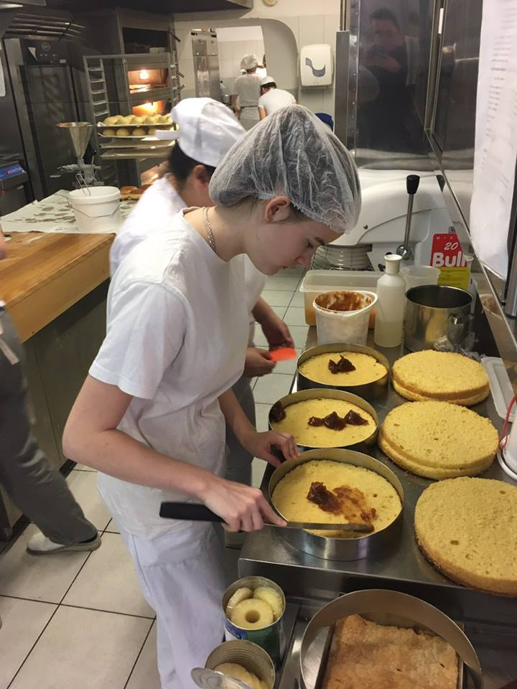

The preservation of the environment is also considered very important in Slovenia. Selective waste collection works well throughout the school.

Personal conditions:
The organizational structure of the school is similar to that of Hungarian schools, but the management has a larger administrative background.

Education system:
The Slovenian vocational training system is similar to Hungarian. The Novo Mesto school is actually a vocational training center (about 1500 students). The proportion of theoretical and practical classes is similar to that of Hungarian vocational training. In theoretical lessons, the emphasis is on applying the project method. The works made in the classrooms and corridors also appear as decorations.
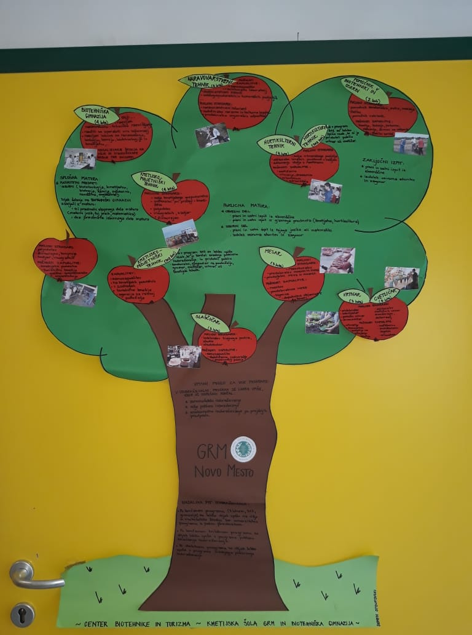

My foreign language competencies have developed in my professional study visit, as our Slovenian colleagues communicate well in English. First of all, my speech skills and vocabulary (professional) developed.
My social and intercultural competences have also been improved by getting to know the cultural background of Slovenia, making personal contacts during our stay.
On the whole, I was very helpful, and I took part in a professional study trip rich in experiences, which I am able to utilize as a deputy head of institution.

Sátoraljaújhely, 25 Mar 2019

Márta Palicz Andrea
professional teacher

