Szabóné Novák Zsuzsa
Accompanying Teacher Report - Slovenian Practice

Between March 2 and March 15 2019, I took part in a Slovenian practice as an accompanying teacher ,where the following students of Georgikon Greek Catholic Agricultural and Food Industrial Secondary and Vocational Training
School and Student Hostel made their professional practice:

Oláh Réka 12. (Food Technician)
Máté Sáfrányos and Csilla Gál 2/10.( confectioners)
Bence Horváth and János Vécsi 1/12 (agricultural mechanic)
Kaskó Krisztián Máté 2/10 (agricultural mechanic student).

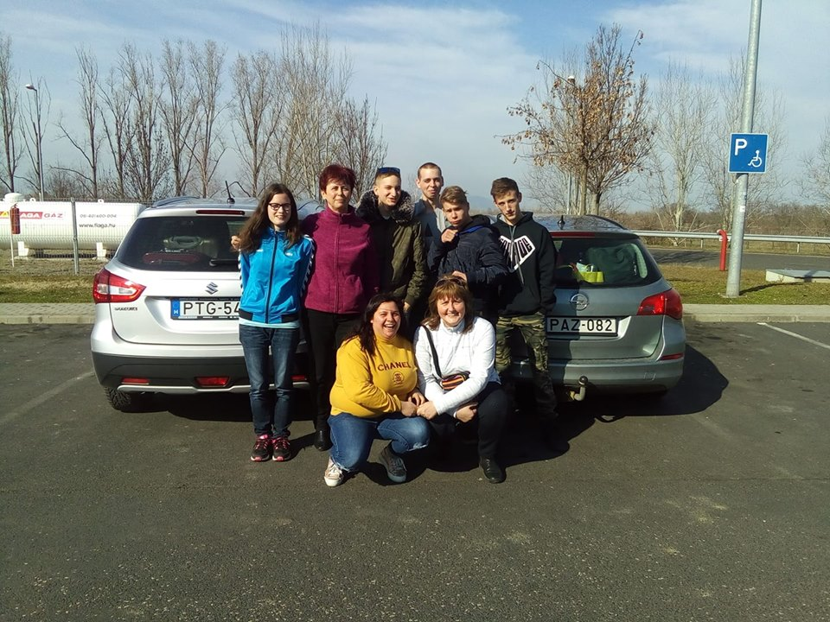

As a coordinator of the application with the members of the school management, our aim was to study the partner institution on the first Slovenian professional program and to control the process of the professional practice. Thanks to the former VITEA, a two-year strategic cooperation program, we got to know the Slovenian partner. There was a good relationship between the institutions during the two years. The talent and precision of Barbara Turk's tender coordinator helped to ensure efficient cooperation and a comprehensive organization.
After setting the time of the practice, the contact was continuous by e-mail, chat, phone - so when we arrived almost everything was arranged.

In accordance with the application program, professional training places were provided. The Slovenian school has beautiful confectionery, a restaurant and a vino. Our confectionery students spent the practice at the confectionery workshop led by Christina - whom we met on the first day and discussed all the other things to do. During the practice we were in contact with her with the help of Barbara. The three students went to the school opposite the accommodation each morning, where they made various cakes and joined the current works.

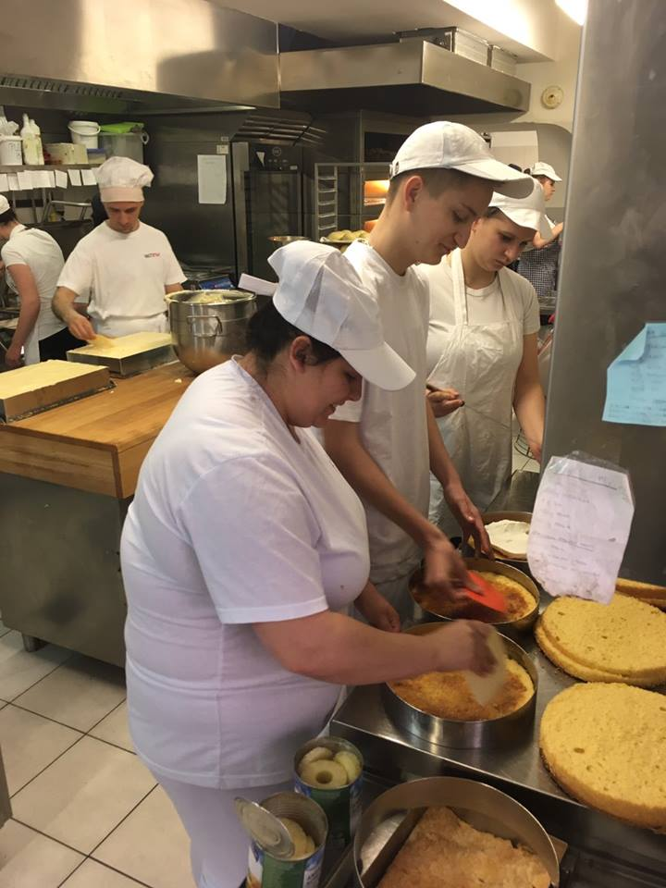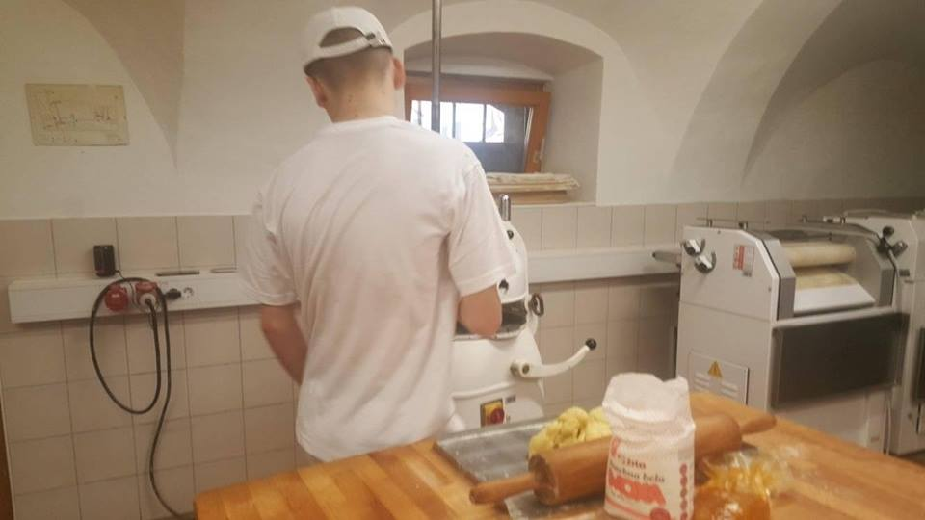

The three mechanic students worked at the school's machine workshop during the practice. The first day when they showed us the school, we could see the beautiful laboratory that was just delivered, which burned a few days before. Our students also helped with the ruin cleaning.

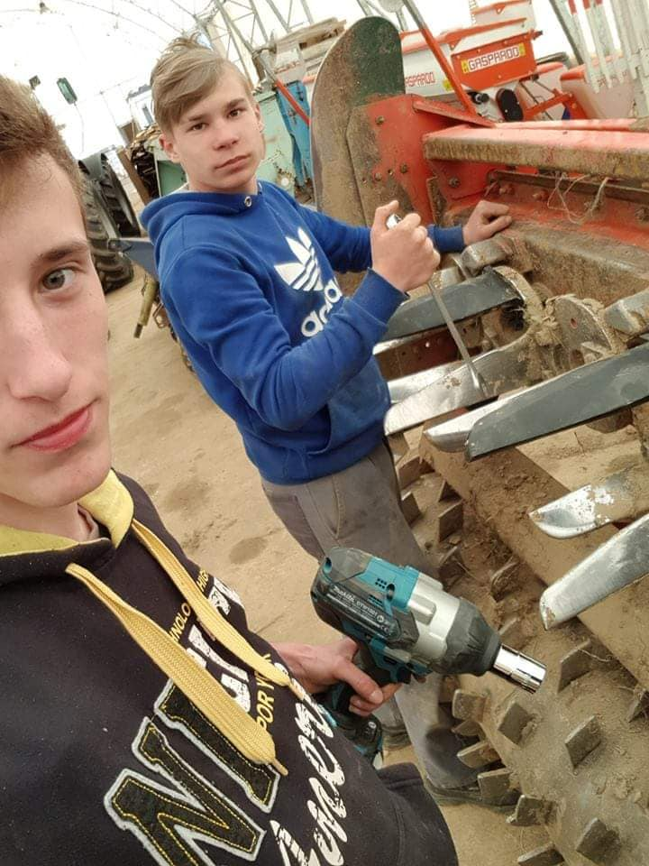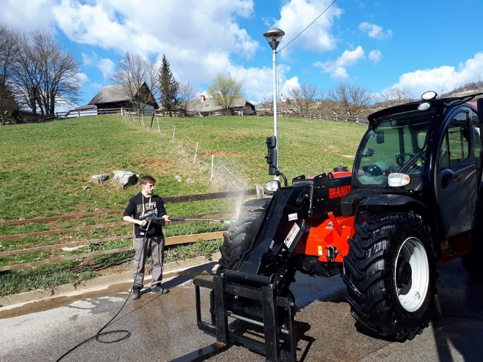

For the first day,we gave the Slovenian colleagues gave documents on the evaluation of learning outcomes in English - to see what criteria will be used to evaluate students. These were collected at the end of the exercise by the exchange colleagues (attached to the attachments)
Before leaving, we completed a self-assessment questionnaire with the students, and then returned home after a return home - so we could evaluate the changes that occurred during the practice.
Accompanying teachers assessed key competencies as a turn, which was agreed at home before the final evaluation of the project and the students received a complex assessment.
Our accommodation was in a small hostel on the main square of Novo Mesto, from where we drove the three mechanic students every day to the 5-kilometer school-training site and we went after them, then together in the school's small restaurant. So we had the opportunity to taste the delicacies of Slovenian gastronomy - much like Hungarian cuisine.

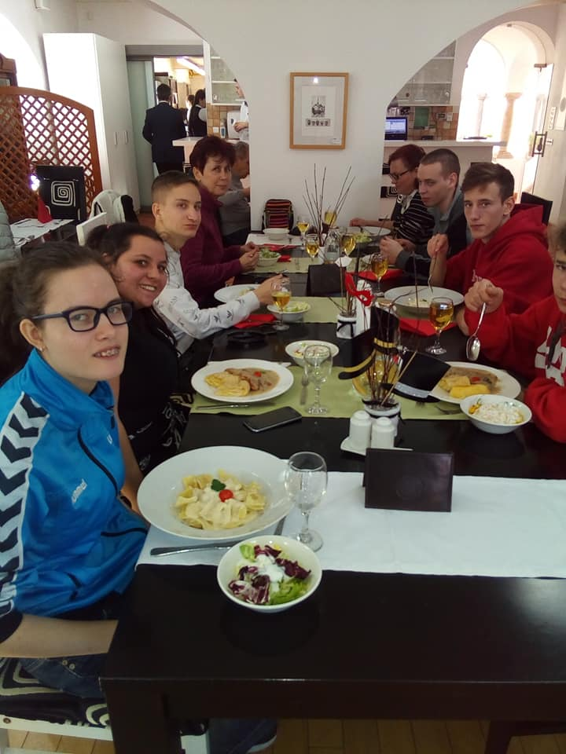
We had our first professional practice where we went by car because of the distance. With a school car and a private car. Of course we were very careful about the insurance and the parents also gave their consent. There were many advantages to using a free car - every day we brought the three boys, we went to the kids to go shopping for dinner every two or three days, and we were free to travel on weekend programs. , which was a great experience for all of us.
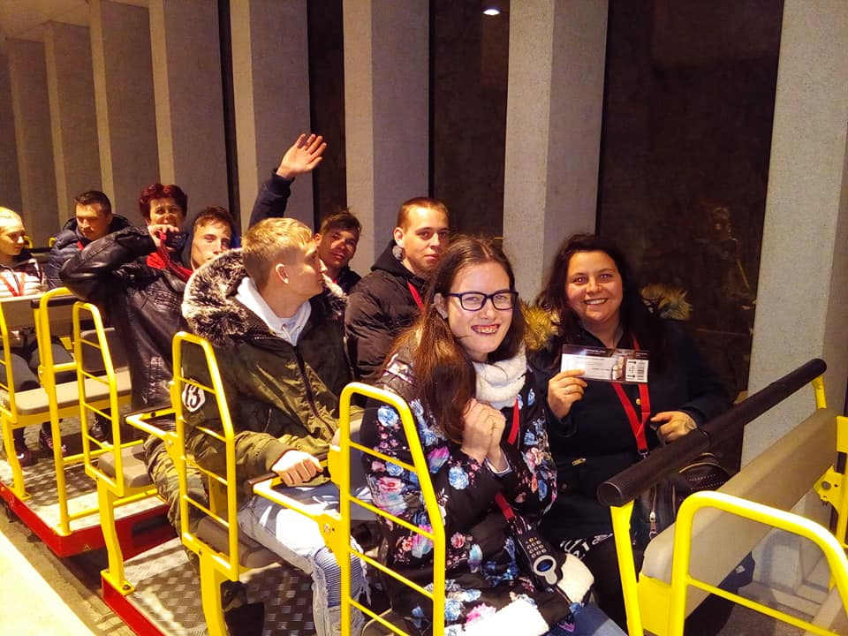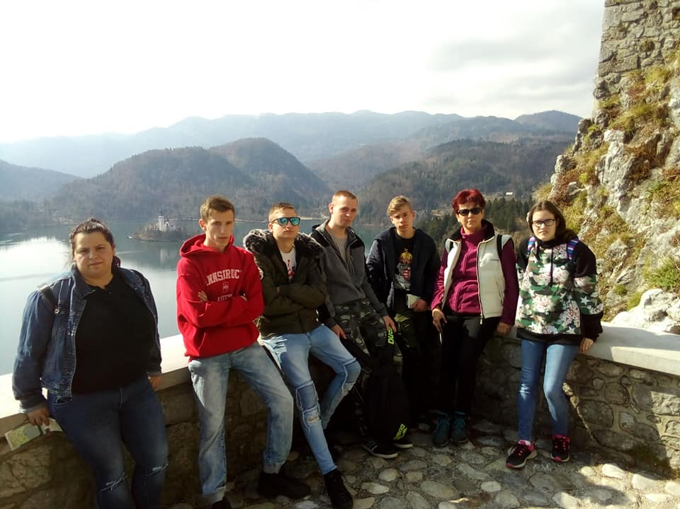

The exchange colleagues arrived on March 14th and it was a day to pass on the students, to report on the experiences, to introduce them to Slovenian colleagues. The confectionery students were surprised by the group for the occasion of the national holiday.
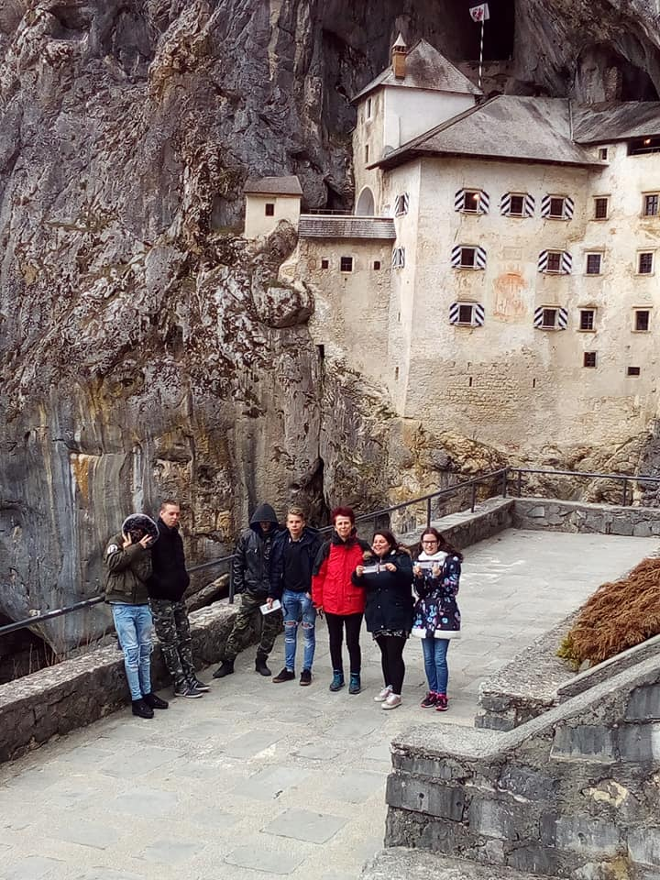

The exchange colleagues arrived on March 14th and it was a day to pass on the students, to report on the experiences, to introduce them to Slovenian colleagues. The confectionery students were surprised by the group for the occasion of the national holiday.

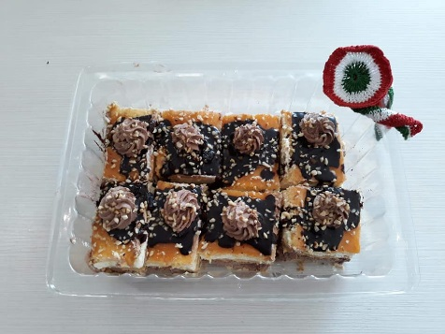

After returning home,three students from the group made main portfolios - for the first time in the Erasmus program (French, Portuguese, Slovenian). We felt it was very important for students to learn how to write a portfolio in small steps - as a newcomer to the labor market value of Europass, they also bring this knowledge to themselves.

At the end of the year, they received the Europass dossier on a solemn basis, consisting of the following documents:
- Europass certificate
- Learning agreement
- Evaluation of learning outcomes
- Evaluation of key competencies
- Self-assessment questionnaires
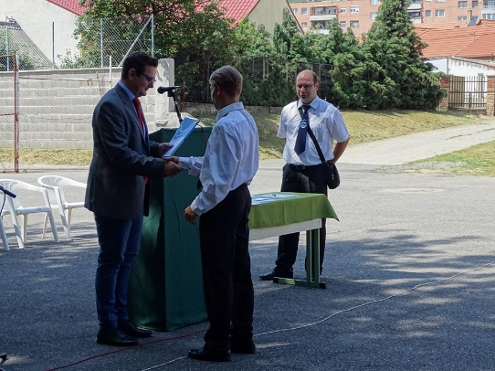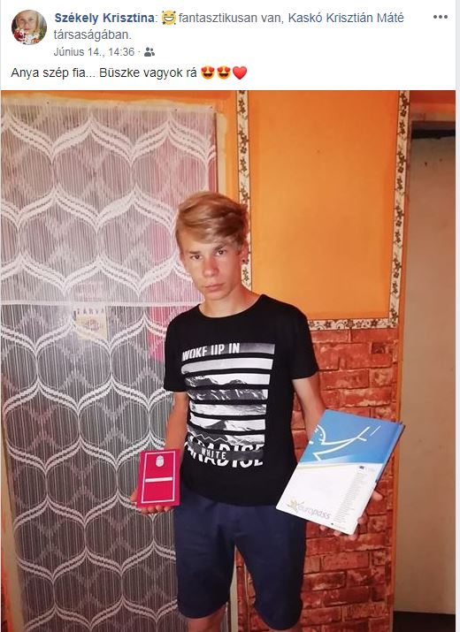

We would like to continue this practice in the future, because we believe that the broadest possible evaluation of the student is better characterized by the employee and that the development of personal and professional competences can be monitored.

Szabóné Novák Zsuzsa
accompanying teacher, coordinator

