Szedlák Zoltán
My Portuguese report
written by Zoltán Szedlák

Thanks to the school, I was able to take part in a traineeship in Portugal, which lasted from November 3rd to November 24th. At this time, three students were out of school. At the beginning of the journey we went by plane and then by bus from Porto to Mirandella.
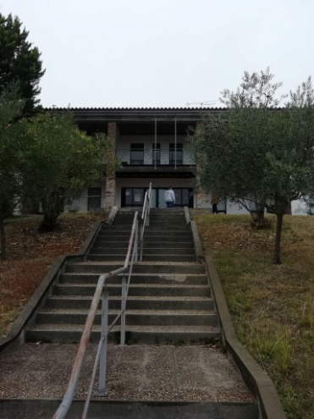
On the first day we visited the city to see their life and culture how is going on, and after a sightseeing tour we went to see a movie together. The mornings usually started as we got up at 7 o'clock and went to have breakfast. After breakfast, we went to our rooms, dressed in work clothes and went to our practical place. At the workplace, we were first led around and showed us what we were doing. They introduced our bosses and our "mentors" there. Immediately the first day we had a tractor welded with us, we were very happy that we could help with the work there. Then we went back to our hotel and went to the city center where we could go shopping. During shopping we could see the city sights, such as: Churches, Bridges, Town Hall.
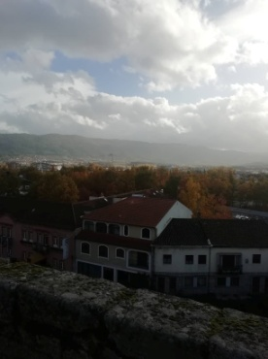
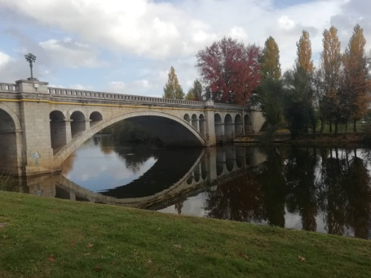
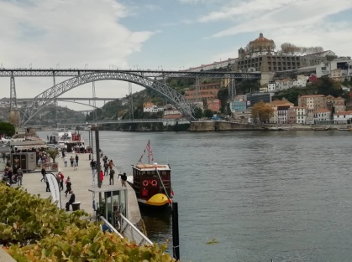

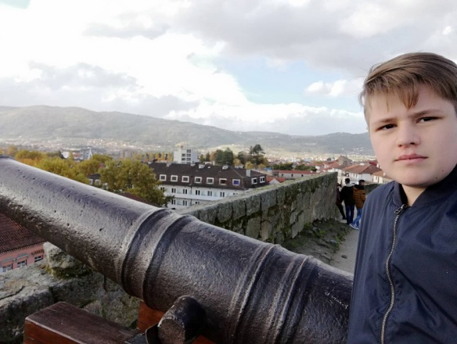
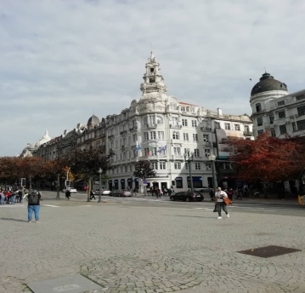

We also had the opportunity to try the specialties there, such as seafood. Usually we got a sandwich for breakfast and a healthy salad and dessert pudding for lunch.
At the accommodation we got to know students from other nationalities, who we got on well despite the language difficulties.
During the time I spent there, I really liked the city of Mirandella and the lifestyle there. On the way back to Porto we could see the Atlantic Ocean, which made me a great experience, as I have seen it for the first time in my life.

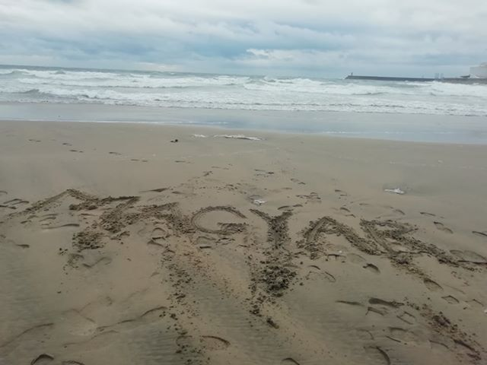

Then we flew back to Hungary.
Thank you very much for taking part in this program, giving me a lot of experience and unforgettable moments.

