Professional summary of Portuguese practice
Venue: Mirandela EPA (Escola Profissional Agricultura)
Date: 2018-11-13-2018

Portugal: European country with almost the same scope as Hungary, located in the southwestern part of the Iberian Peninsula,the westernmost part of the European continent. In the north and east, it borders on a single land neighbor, Spain, its coast washed in the west and south by the Atlantic Ocean. The country was named after the former Count of Porto around Porto.
Portugal includes the Azores (2335 km²) and the Madeira Islands (797 km²) in the Atlantic Ocean. Macao, which returned to China in 1999, was under Portuguese rule for a long time. Long ago (in the mid-1970s), former African colonies (Guinea-Bissau, Angola, Mozambique) became independent.
Students (6 persons) and teachers (1 person of specialized teachers and 1 main attendant teacher) of the Georgikon Greek Catholic Agricultural and Food Industrial Secondary School, Vocational School and Student Hostel,spent three weeks in Portugal under the Erasmus Program in the EPA High School in Mirandola as a host school from 3 to 24 November 2018.

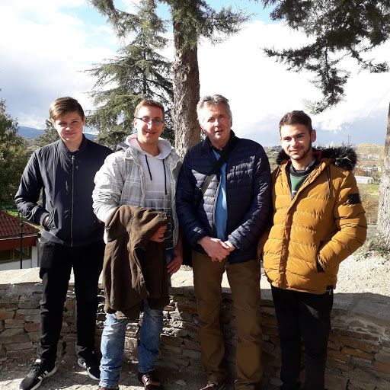
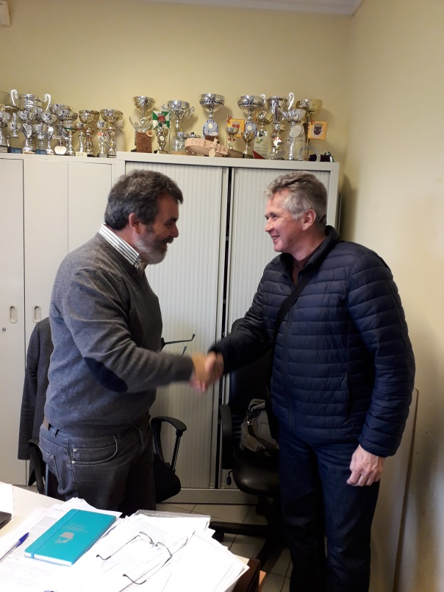

Within the framework of the program, students took part in practical training in the workshops of the school and the companies there. The teachers had the opportunity to see the Escola Profissional de Agricultura (EPA) host school, its training workshops and the specifics of the education there. The program was very concentrated by the host school, but we came home with at least a lot of new knowledge and novelties.
Specialist programs started at 9 o'clock on weekdays and lasted until 4 pm.

Let's see the program in details:

Details of the program
2018.11.13 Arrival in the city of Mirandola in the late evening, occupation of accommodation.
2018.11-14
Wednesday
Professional Program Getting to Know the Leadership and Teachers of the School of Profola Profissional Agriculture (EPA). Meeting with school management and colleagues in professional subjects. Going to school and studying your own field.
15/11/2018
Thursday
Professional program Getting to know the structural, practice workshops, graduate courses and the Portuguese education system of the School of Profola Profissional Agriculture (EPA). Special attention to the issues of vocational training.
Getting to know the partner school's vocational training, studying vocational training documents. View lessons and lesson plans. Watching a lesson in an apprenticeship. Topic: preparation of external professional practices, coordination of eye series with students. Learn about transferable methods, discuss experiences with a Portuguese colleague, exchange experiences, explore further opportunities.
2018. 11.16
Friday
Professional program Walking through the practice places of Hungarian students, getting to know the local conditions.
¬ School Oliva Plant
¬ School Cheese Factory
¬ School Wine Processor
¬ Palas & Palas is an agricultural machinery repair company
17/11/2018
Saturday
Cultural program: Trip to Porto
18/11/2018
Sunday
Cultural program Excursion to the valley of the river Douro to Peso de Requa

19/11/2018
Monday
Professional program: A full-day visit to the school's olive oil processing plant. Study of olive oil production.
20/11/2018
Tuesday
Professional program: A full day visit to the school cheese factory. Studying various cheese making technologies.
21/11/2018
Wednesday
Cultural program: A full-day visit to the wine cellar of the school. Study of white wine and red wine making techniques and machine equipment.
22/11/2018
Thursday
Cultural program: An all-day visit to an agricultural machinery repair company. Studying the repair of various agricultural machines.
23/11/2018
Friday
Professional Program Meeting with the management of the EPA Agricultural School. Director's report, digital education of subjects, practical exercises, weekly reports of students.
24/11/2018
Saturday
Farewell to Portugal, travelling home

Zsolt Goffa
Professional teacher

