Accompanying Teacher Report by Szerdi Hajnalka

Students of Georgikon Greek Catholic Agricultural and Food Industrial Secondary and Vocational School and Student Hostel - Alexandre Horváth 2/13 Food Industrial Class, Kocsi Máté Levente 2/10. Welder, Tibor Oláh 2/10 Agricultural Engineer, and Specialist Teachers (24-12 July 2018 Hajnalka Szerdi, 12/12/2018, Levente Komporday Director) spent three weeks under the Erasmus Portuguese Program in Portugal, in the hospitality of Escola Profissional de Agricultura Calvarhais / Mirandela hostel in Mirandela, Portugal, from November 24 to December 15, 2018.
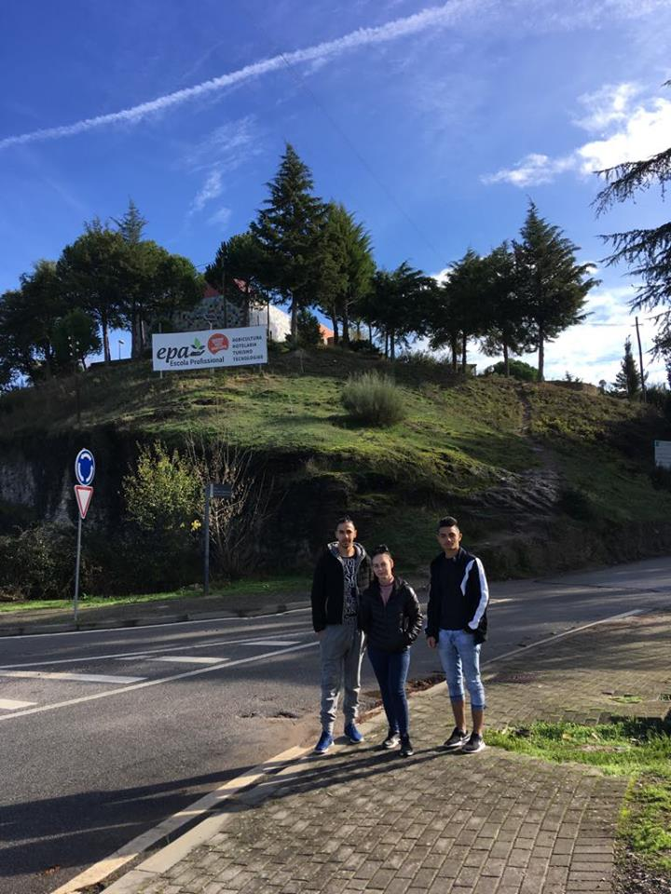

Hungarian students took part in practical training sessions seven hours a day, organized by the host school according to their vocational training in Hungary - agricultural mechanics specialization; welding, food specialization. Kocsi Máté Levente and Tibor Oláh worked in the school's workshop, where they spent most of their working hours repairing and welding engines. In the morning, Alexandra Horváth got acquainted with the cheese making process in the school cheese factory and in the afternoon she worked in the olive processing plant. During the rest of the day and on weekends, they became acquainted with cultural sights, the life of the students there, the eating habits and the mysteries of the Portuguese language.

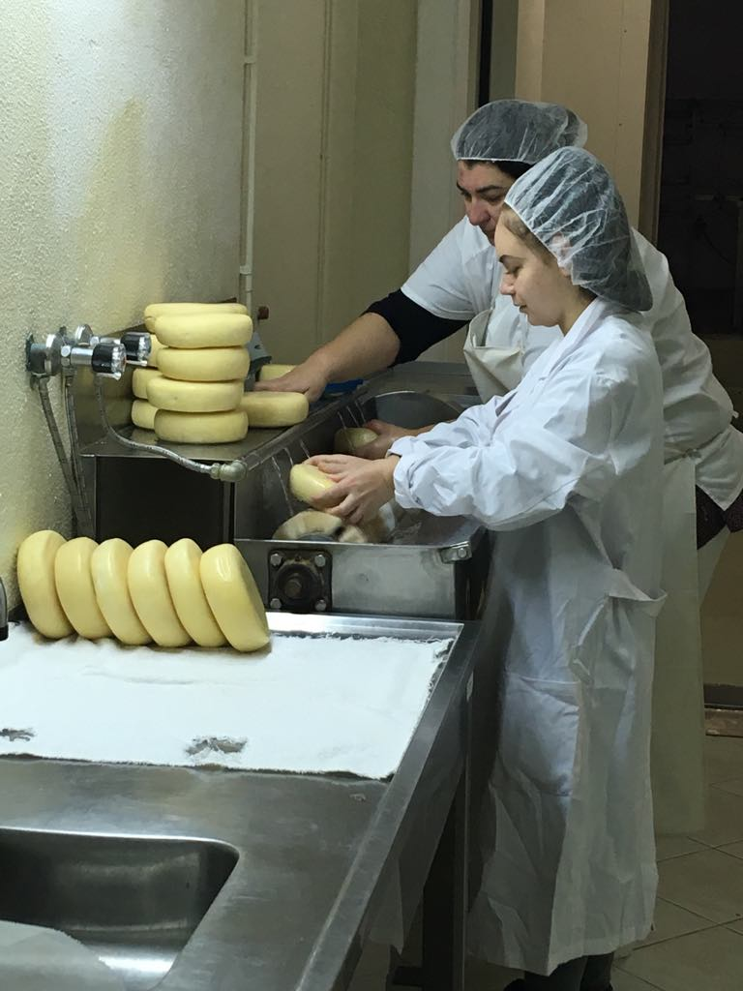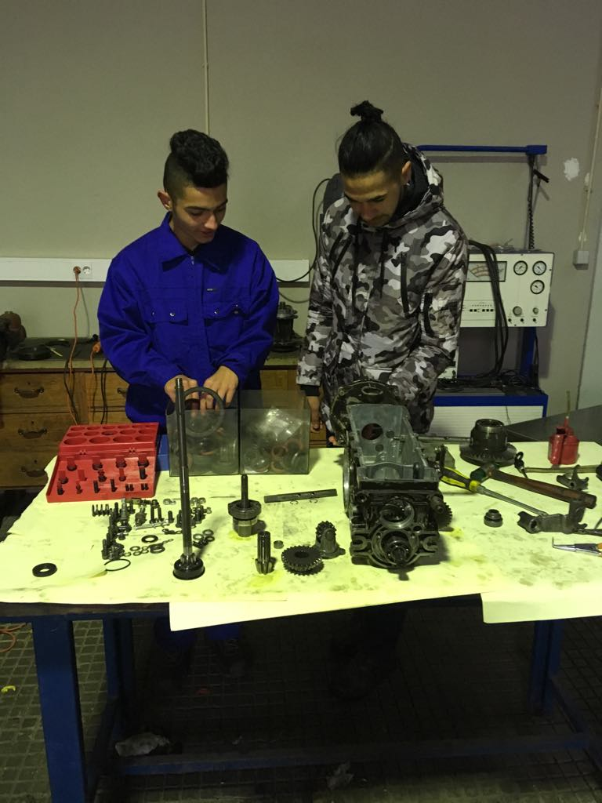

While pupils were on the various exercises, the assistant teachers had the opportunity to study the school's educational system, but they could also attend factory visits, mainly at the local school's food and agricultural businesses. (winery, cheese processing, olive processing).

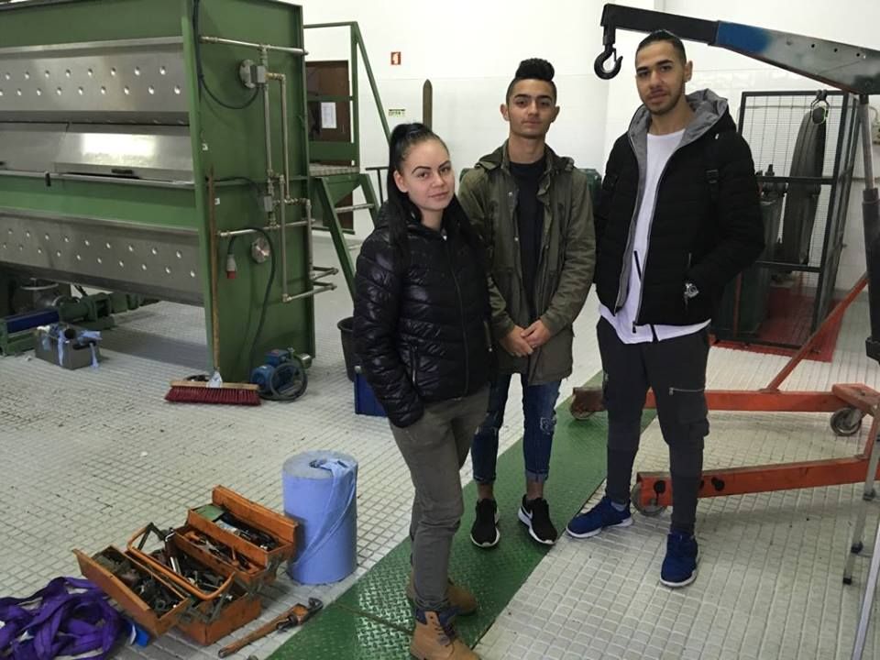

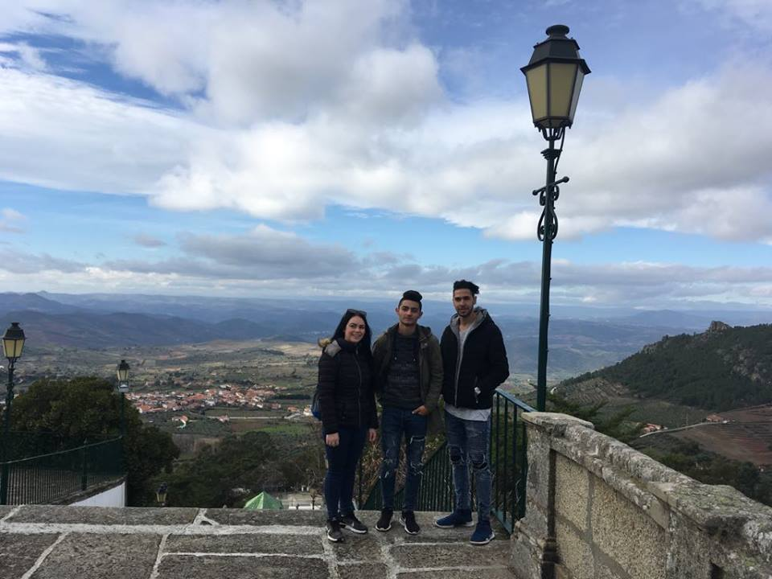

Of course, the most wonderful experience of staying in Portugal was the discovery of the country for everyone.

Sátoraljaújhely, January 15, 2019
Hajnalka Szerdi

