Accompanying Teacher Report by Melinda Moravszky

Students of Georgikon Greek Catholic Agricultural and Food Industrial Secondary School, Vocational School and Student Hostel- Attila Gulyás 2/10 Agricultural Engineer, Zoltán Szedlák 2/10. Welding and István Vámosi 5/13. Melinda Moravszki and Zsolt Goffa, agricultural mechanic's technical and technical teachers, from 3 November to 24 November 2018 spent three weeks in Portugal in Mirandela, Portugal, at the Escola Profissional de Agricultura Calvarhais / Mirandela host school under the Erasmus Portuguese Program. This was the second time that our school had completed student practice in this institution. In this school year, at the request of the host school, students completed two groups of practice. The two groups changed each other.

Pupils took part in professional internships seven hours a day. In accordance with their training, they have completed their practice in private repair companies. The training sites were not unknown to us, because in the last school year we also had our students in these companies. Attila Gulyás and Zoltán Szedlák were at a company where they helped with welding and machine maintenance. István Vámosi took part in similar tasks at another company.
Our accommodation was in the school's college, so we had the opportunity to see the everyday life of the students here. Our meal was organized by the school. During the weekend, we took care of our meals on our trips. During meals we had the opportunity to get acquainted with the diverse dishes of Portuguese cuisine. During their free time and weekend, the students could get acquainted with the country on the programs organized by us, with the sights of the area and the natural treasures. We visit Chaves, Vila Real, Porto, looking at the uniquely beautiful valley of Douro, which is world famous about its vine growing and wine making. During the Douro Valley excursion, the group visited a wine museum where they also got a taste of wine making.
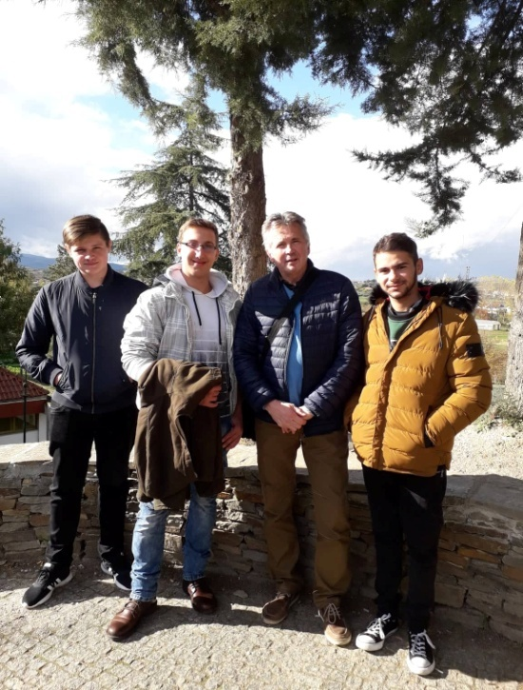
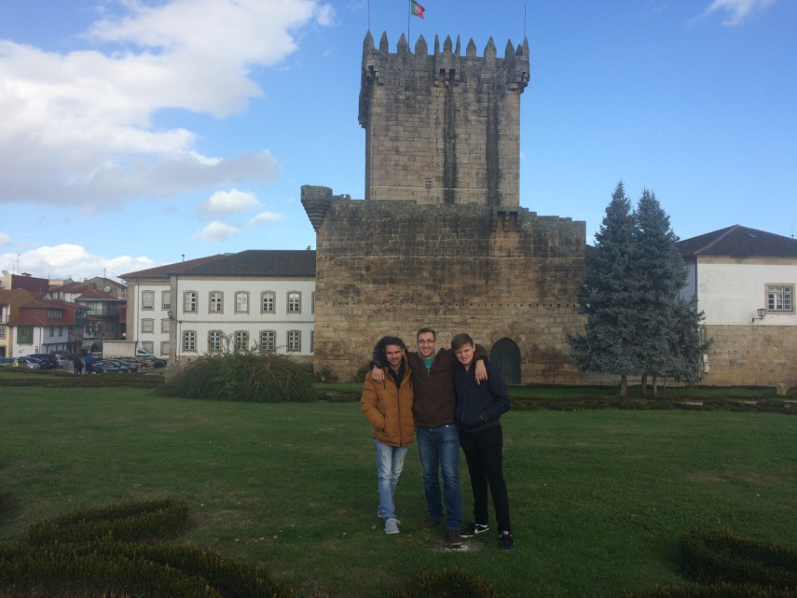

Everybody enriched with the experience of three weeks of professional practice.
Melinda Moravszki, Zsolt Goffa

